Given the root of a binary tree, imagine yourself standing on the **right side** of it, return *the values of the nodes you can see ordered from top to bottom*.

**Example 1:**

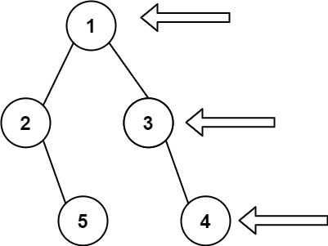

Input: root = [1,2,3,null,5,null,4]  
Output: [1,3,4]

**Example 2:**

Input: root = [1,null,3]  
Output: [1,3]

**Example 3:**

Input: root = []  
Output: []

**Constraints:**

* The number of nodes in the tree is in the range [0, 100].
* -100 <= Node.val <= 100